
Machine learning application

Objective: The purpose of this module is to demonstrate the concept of machine learning through a classical problem in quantum physics: solving the Schrödinger equation for one-dimensional potential wells using a neural network. To illustrate this concept, a pedagogical neural network is trained on a dataset of various potential energy profiles derived from polynomials for which numerical solutions for the wave functions in the ground state or other bound states can be obtained. After training, the model is then used to predict wave functions for previously unseen potentials, showcasing the ability of machine learning to generalize and approximate solutions to complex physical systems.

Activity with the interface
https://qtechedu.centralesupelec.fr/EN/ex3.html

I. Preliminary Questions
For better understanding of the problem presented in this module, you are invited to answer the following theoretical questions in:
Quantum mechanics:
- One-dimensional quantum mechanical systems are determined by their potential functions V(x). What are some examples of these potentials? Are all of them analytically solvable, or do some of them require numerical methods?
Potential | Expression | Key Features | Solvable  Analytically

- What are the main numerical methods used to solve the Schrödinger equation? For each method, provide a brief description, discuss its advantages and limitations, and identify typical use cases. The results may also be organized in a comparative table.

- When we consider potentials of polynomial type$V\left(x\right)=\sum_{i=0}^{d}{α_{i}}x^{i}$, we require that $α_{d}∈ℝ>0$. Why is this necessary? How does whether a system satisfies this requirement influence its behavior, particularly its energy spectrum?
Neural networks:
- Architecture of neural networks is vaguely inspired by biological neural networks. What is an artificial neuron, and what type of mathematical function does it represent? What are neural network layers?

- The time when one ought to write one’s own implementation of neural network architecture using one’s chosen programming language has long passed, as there are many off-the-shelf solutions for that. Could you mention some?

- In the regression task, like the prediction of a wave function, the type of loss function that one chooses is the mean squared error (MSE). What is the interpretation of the mean squared error in terms of minimizing log-likelihood? What distribution of it assumes that the parameters are drawn from? Is it the same distribution from which we draw parameters α?

- When training a neural network, one uses both training and validation datasets. What it the purpose behind it? What is the approximate shape of the training data loss as a function of the epoch, and what is the one for the validation data loss?
II. Operating the QTechEdu Interface
This module focuses on solving the Schrödinger equation using a neural network model, specifically a multi-layer perceptron (MPL). To predict wave functions for arbitrary potentials, the model must first be trained on a dataset containing potentials for which numerical (or analytical) solutions of the Schrödinger equation are available.
The dataset consists of input-output pairs from which the model learns the relationship between a given potential and its corresponding wave function. For simplicity, the potentials are generated using polynomial functions. Therefore:
- Input features: Potentials represented by polynomial functions..
- Output labels: Corresponding wave functions, obtained as numerical solutions of the Schrödinger equation for each potential.
In the section “Training of the Multi-Layer Perceptron", define the parameters of the dataset and the hyperparameters of the neural network model.
- In the left panel of the web interface, choose the parameters for generating the dataset and fill in the table below (please use the interface and the example provided in the table).

Parameters | Description of the dataset parameters
x_{min} = -8  x_{max} = 8 | define the domain 𝒟 = [x_{min} , x_{min}] of the potential V(x),$V\left(x\right)∈𝒟$. Minimum and maximum x determines the potential V(x), recommended intervals for x_{min} and x_{max} are [-10, 0] and [0,10] , respectively.
m = 1
n_{state} =
N =
n_{s} =
N_{s} =

- In the right of the web-interface define the hyper-parameters of the neural network model and fill the table below:
Parameter | Description of the neural network parameters
Learning rate =
Training iterations =
Batch size =

Once the dataset is complete - consisting of generated inputs (potentials) and outputs (wave functions) - it is split into two parts:
- Training set: Used to train the neural network. The model learns by minimizing the error between its predictions and the actual wave functions.
- Validation set: Used to evaluate the model after training. It helps determine whether the model has overfitted (memorized the training data) or generalizes well to unseen data.
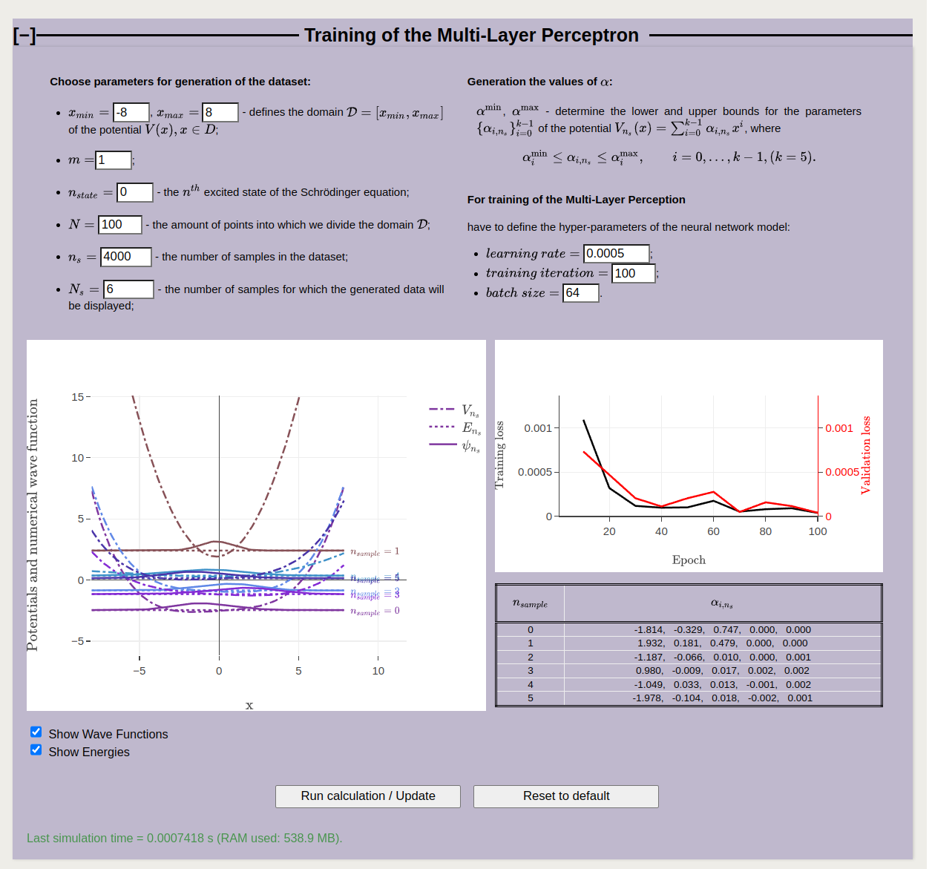

To run the calculation, use the ‘’Run calculation” bottom. To restore the default values, click the “Reset to default” button. In this module, Atomic units are used*.
Attention! Training the system may take some time (about 15 minutes), depending on the selected parameters of the dataset and the neural network model.
The left figure visualizes the randomly chosen polynomial potentials generated during the dataset construction, along with their corresponding wave functions.

- Analyze the parameters and the coefficients α used for generating the set of polynomial potentials. Note the key ideas below:

During training, the machine learning algorithm (model) uses the wave functions values obtained by solving the Schrödinger equation for corresponding potential as the "correct answers" to guide learning.
The neural network is trained to minimize the loss function, which we choose as the mean squared error (MSE) between the actual output values and the predicted ones.
The right figure displays evaluation metrics, including training loss and validation loss, which characterize the results of the training process.

Give definition (as you understand them) for Loss Functions and analyze obtained Loss Functions as a function of the Epoch:

Training loss

Validation loss

Analysis
What does it mean, if the validation loss is much higher than the training loss?

III. Evaluation of Prediction Accuracy
In the Evaluation of the Predictions section, you compare the results obtained using the machine learning model with the numerical solutions of the Schrödinger equation for different types of potentials. You can select both the type of potential and the sample for which the plots are generated.
To evaluate the accuracy of the model's predictions for systems such as the harmonic oscillator and the Morse potential, analyze the wave function and energy plots presented in this section.
Wave function comparison: The target wave function and the wave function predicted by the neural network are displayed in the upper plot. Compare the two curves and evaluate how accurately the predicted wave function reproduces the target solution.
Energy comparison: The lower plot shows the predicted energies as a function of the target energies for all wave functions in the validation dataset. Ideally, all points should lie on the diagonal line, indicating perfect agreement between the predicted and target values.
The figure below shows an example for the Morse potential, illustrating the target and predicted wave functions.
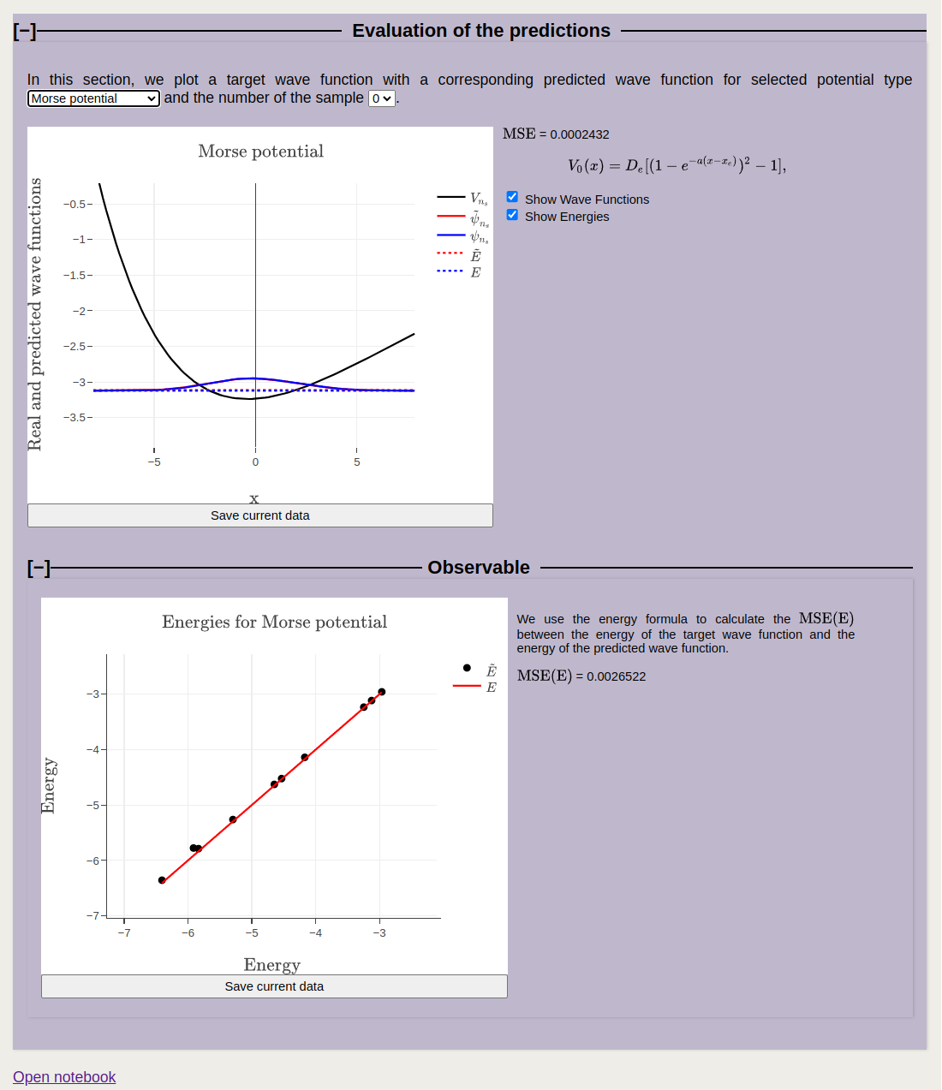
Based on your observations, answer the following questions:
- The parameter N determines the amount of points that are used to determine the quantum mechanical wave function. Inspect how (for a small number of samples) the wave functions change as a function of N. What is the effect on the accuracy of the numerical solution to the Schrödinger equation?

- During training, the class responsible for model training uses the parameter training_iters (variable "training iteration") to control the duration of training. Examine how the training and validation loss curves change as these parameters are varied.
- Compare the MSE for the polynomial potentials, harmonic oscillator and Morse potential. Explain the differences. Why the Morse potential loss is significantly larger, while the harmonic oscillator loss is much closer to the one for polynomial potentials?

- What does representativeness mean in machine learning, and why is it important when creating a training dataset?

* Atomic units https://en.wikipedia.org/wiki/Hartree_atomic_units are used:

the unit of charge is e = 1 (1.602176634×10⁻¹⁹C);
the unit of mass m_{e} = 1 is defined as the mass of the electron (9.1093837139(28)×10⁻³¹ kg);
the unit of action $ℏ$ = 1 - reduced Planck constant (1.054571817...×10⁻³⁴ J⋅s);
the unit of length a₀ = 1 - Bohr radius ($a_{0}={4πεℏ^{2}}/{m_{e}e^{2}}$= 0.529×10⁻¹⁰m);
the unit of energy E_{H} = 1 - Hartree energy ($E_{H}={ℏ^{2}}/{m_{e}a_{0}^{2}}$= 4.359×10⁻¹⁸ J = 27.211 eV).

